
St Albans City & District
Community-wide Emissions Summary 2025

Background Information for Data Analysis
Data Source: The Department for Energy Security and Net Zero (DESNZ) release area-wide emission statistics broken down by local authority area each year. The latest report was released on 3rd July 2025. This report is based upon Table 2.1: Local Authority territorial carbon dioxide (CO₂) emissions estimates within the scope of influence of Local Authorities 2005-2023 (kt CO2e).
Timescales: Due to the complexity of the data gathering exercise, the most recent information is always 18 months old. This means that the 2025 report shows data for emissions in St Albans District up to 2023.Data is provided on a calendar year basis.
Greenhouse Gases: From 2005-2020 the data covered only carbon-dioxide. This latest report also includes methane (CH₄) and nitrous oxide (N₂O). In accordance with international reporting and carbon trading protocols, each of these gases is weighted by its global warming potential, so that total greenhouse gas emissions can be reported on a consistent basis (in (CO₂ equivalent units - CO₂e).
DESNZ data is available for emissions from hydrofluorocarbons, perfluorocarbons, sulphur hexafluoride and nitrogen trifluoride (collectively referred to as fluorinated gases or F gases), but they are unable to allocate these emissions at a local authority level. While F gases make up only 2% of overall UK emissions, their exceptional warming potential means that their global warming potential is up to 26,000 times that of CO₂. Abatement technologies at production plants have cut F-gas leakage by over 99%. The largest source of emissions is now the refrigeration, air-conditioning and heat pump sector, due to refrigerant leakage from appliances during use and disposal.
Updates: Each year the datasets are revised to take into account methodological improvements and so this year’s dataset supersedes and replaces all previous reports.
Scope of Data: The emissions estimates used do not include emissions from motorways, air travel, consumption of foods and products, fluorinated gases large industrial sites, diesel railways, motorways, land use, livestock and soils. The District’s footprint will therefore, in reality, be significantly higher.
Data: A summary of the data is provided in Appendix 1.

Executive Summary
St Albans District has reduced its greenhouse gas emissions by 48% since 2005, but current rates fall short of the pace needed to meet our 2030 net zero target. Urgent acceleration is required to close the gap and align with our climate commitments.

Headlines
Total Emissions (2023): 458,400 tonnes of GHG
Recent Reductions: Emissions dropped by 8% between 2021 and 2022, and then a further 7% by 2023.
Long-Term Progress: Overall emissions are now 48% lower than in 2005, primarily due to decarbonisation of the National Grid.
Per Capita Emissions: Fell from 6.6 tCO₂ to 3.1 tCO₂ in 2023 and are now comparable with Stevenage and Hertsmere.
County Comparisons: Watford and Broxbourne have the lowest per capita emissions in Hertfordshire at 2.5 tCO₂ and 2.8 tCO₂ respectively.
Emissions per km²: St Albans City and District 2.8 tCO₂km² is higher than the South East (1.6 tCO₂km²) and East of England average (1.2 tCO₂km²) reflecting higher population density in this area.
Transport Emissions: Minimal change since the previous year.
Domestic Emissions: The largest contributor to emissions, just slightly higher than transport sources.
Hertfordshire Ranking: St Albans District falls 4th highest when compared against the other Districts and Borough Councils. We have particularly high emissions from domestic energy given the age of our buildings. Our domestic emissions are twice that of Stevenage’s – which was largely built in the 1950’s/1960’s.

Progress Towards Community-wide Decarbonisation
In 2019, St Albans District Council declared a climate emergency and committed to achieving net zero community-wide greenhouse gas emissions by 2030. To meet this goal, we initially set an annual reduction target of 47,000 tonnes CO₂e starting from 2018.
However, due to shortfalls in meeting these yearly milestones, the required pace of decarbonisation has increased. In 2024, the revised annual reduction target rose to 61,000 tonnes CO₂e, reflecting the need to accelerate progress.
The latest data shows a 48% reduction compared to the 2005 baseline. However, with only five years remaining until 2030, we should already be at a 72% reduction to remain on track.
The observed annual rate of reduction is around 23,000 tonnes CO₂e, which is less than half the rate required to achieve the decarbonisation target. If reductions continue at this pace, the District is projected to reach net zero by 2042 - 12 years behind our target.
While this trajectory aligns with the UK Climate Change Act target of achieving Net Zero by 2050, it falls short of the Paris Agreement ambition to limit global temperature rise to well below 2°C, ideally 1.5°C. Rapid and sustained reductions are now essential.
While we anticipate more rapid rates of decarbonisation as national policies and funding mechanisms are introduced to support renewable energy, low-emission transport, and home retrofit programmes, we understand the importance of local action.
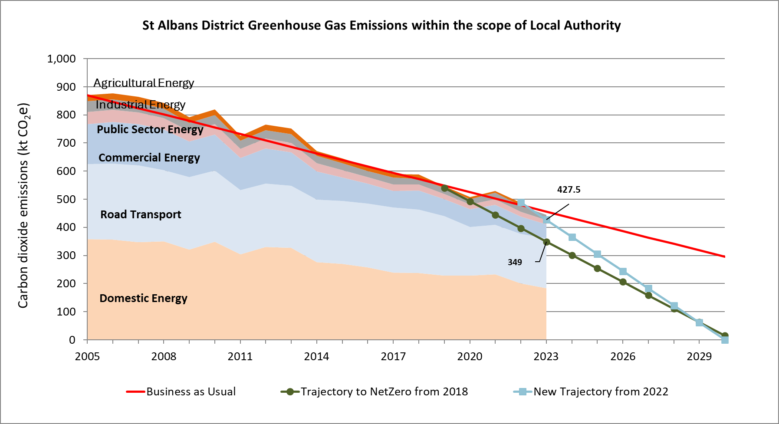
Conclusion
While we remain committed to doing all that we can, we recognise that fully decarbonising all transport and buildings within the remaining five years is not achievable given the national and county-level investment and policy available. As a District Council we are limited in our powers to affect local transport, industry, agriculture or the way residents use energy to power their homes. Nonetheless, we will continue to act ambitiously and collaboratively, making sure that environmental sustainability is taken into account in all decisions.
We will continue to lead by example, accelerating the decarbonisation of our built assets, ensuring sustainable development through planning policy, and removing barriers to behaviour change and increasing knowledge levels. This includes working with Herts County Council to expand electric vehicle infrastructure and supporting residents and businesses to access retrofit funding and energy advice.

Appendix 1: Local authority territorial carbon dioxide (CO2) emissions estimates within the scope of influence of local authorities 2005-2023 (kt CO2e) for St Albans District

https://www.gov.uk/government/statistics/uk-local-authority-and-regional-greenhouse-gas-emissions-statistics-2005-to-2023

